**Compare Jibble vs Jira**

What is better Jibble or Jira? Finding the right Project Management Software product is as simple as assessing the strong and weak functions and terms offered by Jibble and Jira. Here it's also possible to match their total scores: 8.1 for Jibble vs. 9.3 for Jira. Or you can verify their general user satisfaction rating, 100% for Jibble vs. 97% for Jira.

We suggest that you spend some time to analyze their differences and figure out which one is the better choice for your company. Likewise, don’t forget to take into account your company’s or industry’s special circumstances, for example, a multilingual software for a global team or a mobile platform to help you work in the field.

Currently, the top services in our Time Tracking Software category are: ProjectManager, monday.com, Time Doctor.

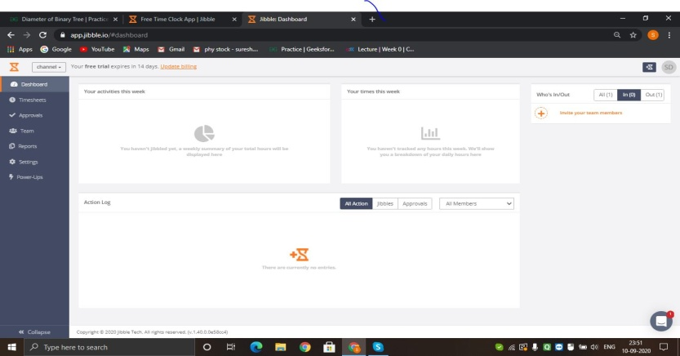

**List of Features(Jibble)**

* Timesheets & Reports
* Stats & Alerts
* Activity Tracking
* Client Billing
* Export
* Collaboration
* Policies
* Passcodes
* Geolocation

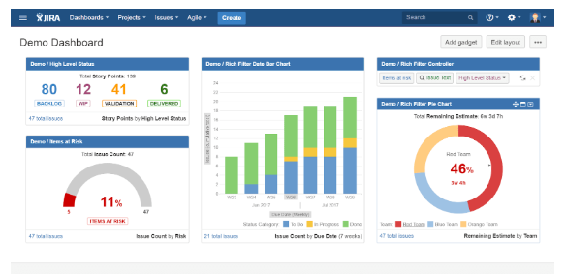

**List of Features(JiRA)**

* Customizable workflows
* Unlimited custom fields
* Bugs and defect management
* Seamless source and issue integration
* Search and filtering
* Advanced reporting
* Customizable dashboards and wallboards
* Advanced security and administration
* Integration with flexible REST APIs
* Easily import data from other systems
* Mobile interface
* OnDemand and OnPremise deployment
* Scrum, Kanban, and Scrumban boards
* Polished user experience
* Google authentication
* **Problem #1: Software teams’ lack of means to monitor their progress can cause delay issues.**

**Solution:**Software teams are unable to ship new products or features on time because they lack a streamlined way to track who is doing what, so work gets delayed or lost entirely in outdated spreadsheets. Jira Software keeps work moving forward by keeping the entire team on the same page about work that has been completed and what still need needs to be done. At the heart of Jira is the board, which tracks every item of work needed in the workflow. Now individual team members have a single place to report the status of their work; and management can see the overall status of every active project via the roadmap view.

* **Problem #2: Agile methodologies are harder to implement and adapt to.**

**Solution:**Teams moving toward or practicing an agile framework rely on Jira Software to implement this iterative approach to project management. Jira Software offers Scrum and Kanban boards out-of-the-box so teams can implement an agile framework with ease. And with a number of reports, agile teams can monitor their progress to ensure they are achieving their goals.

* **Problem #3: Complex processes involving different tools that don’t speak to each other can slow software development process.**

**Solution:**Jira Software is open and flexible by design, so data from other systems flows seamlessly into Jira Software and provides teams with the information they need in context. With thousands of apps to choose from on the Atlassian Marketplace, software development teams can connect their Jira Software instance to their source code data, CICD, monitoring systems, productivity apps, and design tools.

Slack(Cons..)

* **Adoption:** “not yet another app to install!” If a lot of your team members aren’t tech-enthusiasts, it may be difficult to get them all on board to use Slack. However, it’s remarkably intuitive to use, and your team may be surprised by how much everyone likes it!
* **Technology hurdles:** if members of your team don’t have a smartphone, they won’t be able to use Slack when away from their computers. So you might want to get a feel for just how much this will impact the team before adopting Slack as a primary communications platform.
* **Slack is less ideal for:** major decision-making discussions, collaboration on large-scale projects (big documents, for example).

